*<?*xml version="1.0" encoding="utf-8"*?>*

<selector xmlns:android="http://schemas.android.com/apk/res/android">

<item>

<shape android:shape="rectangle">

<solid android:color="@color/purple_200"></solid>

<stroke android:color="#03045E"

android:width="5dp"

android:dashGap="2px">

</stroke>

<corners android:bottomLeftRadius="30dp" android:topRightRadius="30dp">

</corners>

<size android:width="200dp" android:height="200dp"></size>

<gradient android:startColor="#00B4D8" android:endColor="#90E0EF" android:angle="180"

android:centerColor="#CAF0F8"

android:type="radial"

android:gradientRadius="80dp"

android:centerX="1"

android:centerY="0">

</gradient>

</shape>

</item>

</selector>

*<?*xml version="1.0" encoding="utf-8"*?>*

<androidx.constraintlayout.widget.ConstraintLayout xmlns:android="http://schemas.android.com/apk/res/android"

xmlns:app="http://schemas.android.com/apk/res-auto"

xmlns:tools="http://schemas.android.com/tools"

android:layout_width="match_parent"

android:layout_height="match_parent"

tools:context=".MainActivity">

<ImageButton

android:id="@+id/imageButton"

android:layout_width="218dp"

android:layout_height="178dp"

app:layout_constraintBottom_toBottomOf="parent"

app:layout_constraintEnd_toEndOf="parent"

app:layout_constraintStart_toStartOf="parent"

app:layout_constraintTop_toTopOf="parent"

app:srcCompat="@drawable/custom_bg" />

</androidx.constraintlayout.widget.ConstraintLayout>

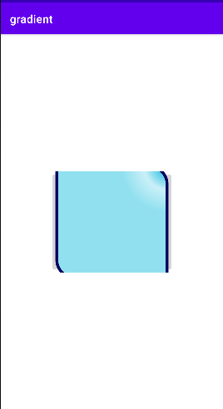

Themes

XML code

*<?*xml version="1.0" encoding="utf-8"*?>*

<androidx.constraintlayout.widget.ConstraintLayout

xmlns:android="http://schemas.android.com/apk/res/android"

xmlns:tools="http://schemas.android.com/tools"

xmlns:app="http://schemas.android.com/apk/res-auto"

android:layout_width="match_parent"

android:layout_height="match_parent"

tools:context=".MainActivity">

<EditText

android:id="@+id/editTextTextPersonName"

android:layout_width="wrap_content"

android:layout_height="wrap_content"

android:ems="10"

android:inputType="textPersonName"

android:text="Name"

app:layout_constraintBottom_toBottomOf="parent"

app:layout_constraintEnd_toEndOf="parent"

app:layout_constraintStart_toStartOf="parent"

app:layout_constraintTop_toTopOf="parent" />

</androidx.constraintlayout.widget.ConstraintLayout>

themes

<resources xmlns:tools="http://schemas.android.com/tools">

*<!-- Base application theme. -->*

<style name="Theme.new_style" parent="Theme.MaterialComponents.DayNight.DarkActionBar">

*<!-- Primary brand color. -->*

<item name="colorPrimary">@color/primary</item>

<item name="colorPrimaryDark">@color/primary_dark</item>

<item name="colorAccent">@color/color_accent</item>

<item name="android:textColorPrimary">@color/color_text</item>

<item name="android:textSize">40dp</item>

</style>

</resources>

Manifest

*<?*xml version="1.0" encoding="utf-8"*?>*

<manifest xmlns:android="http://schemas.android.com/apk/res/android"

package="com.example.themes" >

<application

android:allowBackup="true"

android:icon="@mipmap/ic_launcher"

android:label="@string/app_name"

android:roundIcon="@mipmap/ic_launcher_round"

android:supportsRtl="true"

android:theme="@style/Theme.new_style" >

<activity

android:name=".MainActivity"

android:exported="true" >

<intent-filter>

<action android:name="android.intent.action.MAIN" />

<category android:name="android.intent.category.LAUNCHER" />

</intent-filter>

</activity>

</application>

</manifest>

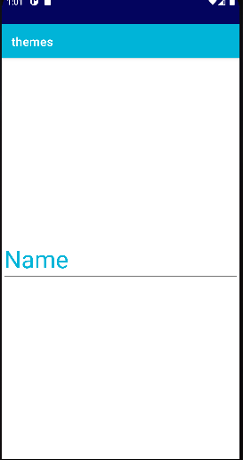

Navigation drawer

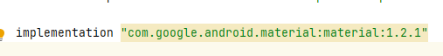

XML Code

*<?*xml version="1.0" encoding="utf-8"*?>*

<androidx.drawerlayout.widget.DrawerLayout xmlns:tools="http://schemas.android.com/tools"

xmlns:android="http://schemas.android.com/apk/res/android"

xmlns:app="http://schemas.android.com/apk/res-auto"

android:id="@+id/drawer"

android:layout_width="match_parent"

android:layout_height="match_parent"

tools:context=".MainActivity"

layout_width=""

layout_height=""

tools:ignore="InvalidId">

<LinearLayout

android:layout_width="match_parent"

android:layout_height="match_parent"

android:orientation="vertical">

<TextView

android:id="@+id/textView"

android:layout_width="match_parent"

android:layout_height="wrap_content"

android:text="Welcome" />

</LinearLayout>

<com.google.android.material.navigation.NavigationView

android:id="@+id/nav_view"

android:layout_height="match_parent"

android:layout_width="match_parent"

app:menu="@menu/nav_menu"

android:layout_gravity="start"

>

</com.google.android.material.navigation.NavigationView>

</androidx.drawerlayout.widget.DrawerLayout>

Nav_menu.xml

*<?*xml version="1.0" encoding="utf-8"*?>*

<menu xmlns:android="http://schemas.android.com/apk/res/android">

<item

android:id="@+id/nav_account"

android:title="My Account">

</item>

<item

android:title="setting"

android:id="@+id/set">

</item>

<item

android:id="@+id/logout"

android:title="Logout">

</item>

</menu>

Strings.xml

<resources>

<string name="app_name">navigationdraw</string>

<string name="nav_open">Open</string>

<string name="nav_close">Close</string>

</resources>

Java code

MainActivity.java

package com.example.navigationdraw;

import androidx.annotation.NonNull;

import androidx.appcompat.app.ActionBarDrawerToggle;

import androidx.appcompat.app.AppCompatActivity;

import androidx.drawerlayout.widget.DrawerLayout;

import android.os.Bundle;

import android.view.MenuItem;

import android.widget.Toast;

import com.google.android.material.navigation.NavigationView;

public class MainActivity extends AppCompatActivity implements NavigationView.OnNavigationItemSelectedListener {

DrawerLayout dr;

ActionBarDrawerToggle at;

@Override

protected void onCreate(Bundle savedInstanceState) {

super.onCreate(savedInstanceState);

setContentView(R.layout.*activity_main*);

dr=findViewById(R.id.*drawer*);

at=new ActionBarDrawerToggle(this,dr,R.string.*nav_open*,R.string.*nav_close*);

dr.addDrawerListener(at);

at.syncState();

getSupportActionBar().setDisplayHomeAsUpEnabled(true);

NavigationView nv=findViewById(R.id.*nav_view*);

nv.setNavigationItemSelectedListener(this);

}

@Override

public boolean onOptionsItemSelected(@NonNull MenuItem item) {

if (at.onOptionsItemSelected(item))

{

return true;

}

return super.onOptionsItemSelected(item);

}

@Override

public boolean onNavigationItemSelected(@NonNull MenuItem item) {

int id=item.getItemId();

if(id==R.id.*nav_account*){

Toast.*makeText*(this, "Home Page", Toast.*LENGTH_SHORT*).show();

}

if(id==R.id.*set*){

Toast.*makeText*(this, "Setting page", Toast.*LENGTH_SHORT*).show();

}

if(id==R.id.*logout*){

Toast.*makeText*(this, "Logout page", Toast.*LENGTH_SHORT*).show();

}

return false;

}

}

OUTPUT

